New Employee Orientation

2013



Children's Healthcare of Atlanta

**Agenda & Table of Contents**

|  |  |  |  |  |  |
| --- | --- | --- | --- | --- | --- |
| **Day 1** | | | | | |
| **Time** | | | **Topic** | **Page #** | |
|  | | | Contacts | 2 | |
|  | | | Acronym Guide | 3-4 | |
|  | | | Login Tipsheet | 5-6 | |
| 8:30 | - | 9:15 | Senior Leader Welcome | 7-8 | |
| 9:15 | - | 9:30 | General Welcome |  | |
| 9:30 | - | 10:15 | Infection Prevention & Back Safety | 9-10 | |
| 10:15 | - | 10:30 | Break |  | |
| 10:30 | - | 11:15 | Safety | 11-12 | |
| 11:15 | - | 12:00 | Security | 13-14 | |
| 12:00 | - | 1:00 | Lunch |  | |
| 1:00 | - | 1:15 | Mandated Reporting | 15-16 | |
| 1:15 | - | 2:00 | Compliance | 17-18 | |
| 2:00 | - | 2:15 | HIPAA | 18 | |
| 2:15 | - | 2:30 | Break |  | |
| 2:30 | - | 3:15 | HR | 19 | |
| 3:15 | - | 4:00 | Customer Service | 20 | |
| **Day 2** | | | | | |
| **Time** | | | **Topic** | | **Page #** |
| 8:30 | - | 9:30 | Total Rewards - Benefits | | Handout |
| 9:30 | - | 9:45 | Aflac | | Handout |
| 9:45 | - | 10:00 | Break | |  |
| 10:00 | - | 11:00 | Total Rewards - Worklife | | 21-22 & Handout |
| 11:00 | - | 12:30 | Technology Training | | 23-26 |
| 12:30 | - | 1:30 | Lunch | |  |
| 1:30 | - | 1:45 | Fidelity | | Handout |
| 1:45 | - | 2:30 | Payroll | | 27-34 |
| 2:30 | - | 12:45 | Break | |  |
| 2:45 | - | 3:15 | Learning Game | |  |
| 3:15 | - | 4:00 | Foundation | | 35-36 |
|  |  |  | Your 1st Year Connection: Taleo Onboarding | | 37 |
|  |  |  | Additional Information | | 38 |

**Contacts**

|  |  |  |  |
| --- | --- | --- | --- |
| **Name** | **Contact** | **Number** | **Website** |
| **Aflac** | Jennifer Carnahan | 678-521-6382 | [www.aflac.com](http://www.aflac.com) |
| **Compliance Hotline** |  | 1.877.373.0126 | <http://choa.alertline.com> |
| **Fidelity (Main line)** |  | 1.800.343.0860 | [www.fidelity.com](http://www.fidelity.com) |
| **Fidelity Reservation** | Jason Bleeker | 1.800.642.7131 | [www.fidelity.com/reserve](http://www.fidelity.com/reserve) |
| **Foundation** |  | 404-78**5-GIVE** | <https://giving.choa.org/sslpage.aspx?pid=298> |
| **HR** |  | 404.78**5**.**4747** |  |
| **Infection Prevention** |  | 404.78**5.0577** |  |
| **IS & T Helpdesk** |  | 404.78**5**.**6767** |  |
| **Needlestick Hotline** |  | 404.78**5.7777** |  |
| **Occupational Health:**  **The Park:** Building 1655 – Ste. E |  | 404.78**5.2228** |  |
| **Parking:**  **Egleston & Scottish Rite** | Bruce Byrd | 404.78**5.3440** |  |
| **Parking - Hughes Spalding** | Roscoe Simmons | 404.78**5.6811** |  |
| **Security (Emergency)** |  | **5.6161** or9.911 |  |
| **TIME** |  | **5.8463** |  |

**Children’s Standard Acronym Guide**

|  |  |  |
| --- | --- | --- |
| Category | Acronym | Acronym Description |
| Campus/Centers | Aflac | Aflac Cancer and Blood Disorders Center |
|  | ECC | Emory Children’s Center |
|  | EGL/ECH | Children's at Egleston |
|  | HS | Children’s at Hughes Spalding |
|  | Marcus/MAC | Marcus Autism Center |
|  | MOB | Children's Medical Office Building |
|  | SR | Children's at Scottish Rite |
| Departments | CBO | Central Billing Office |
|  | CSO | Central Staffing Office |
|  | EPG | Egleston Pediatric Group |
|  | EVS | Environmental Services |
|  | IS&T | Information Systems & Technology |
|  | SRPAC | Scottish Rite Pediatric and Adolescent Consultants |
| Clinical Departments | CICU | The Children's Healthcare of Atlanta Michael P. Fisher Cardiac Intensive Care Unit |
|  | CIRU | Comprehensive Inpatient Rehabilitation Unit |
|  | CSU | Cardiac Stepdown Unit |
|  | ED/ER | Emergency Department |
|  | HemOnc | Hematology/Oncology (cancer) |
|  | ICU | Intensive Care Unit |
|  | Med/Surg | General Patient Care Units |
|  | NICU | Neonatal Intensive Care Unit |
|  | PACU | Post Anesthesia Care Unit |
|  | PICU | Pediatric Intensive Care Unit |
|  | TICU | Technology-Dependant Intensive Care Unit |
|  | TSU | Transplant Stepdown Unit |
| Medical Acronyms | I.V. | Intravenous |
|  | ECMO | Extracorporeal Membrane Oxygentation |
|  | BMT | Blood and Marrow Transplant |
|  | CT | Computed Tomography (x-ray) |
|  | MRI | Magnetic Resonance Imaging (x-ray) |

**Children’s Standard Acronym Guide (cont.)**

|  |  |  |
| --- | --- | --- |
| Category | Acronym | Acronym Description |
| Other Important Acronyms | AOC | Administrator On Call |
|  | Children’s/CHOA | Children’s Healthcare of Atlanta |
|  | CAN | Career Advancement for Nursing |
|  | CAR | Career Advancement for Respiratory |
|  | CISM | Critical Incident Stress Management |
|  | CMS | Centers for Medicare and Medicaid Services |
|  | COWS/WOWS | Computers on Wheels/Workstations on Wheels |
|  | HCFA | Health Care Finance Administration |
|  | HICS | Hospital Incident Command System |
|  | HIE | Healthcare Information Exchange |
|  | HIPAA | Health Insurance Portability Accountability Act |
|  | HRIS | Human Resources Information Systems |
|  | ICD-10 | International Statistical Classification of Diseases and Related Health Problems |
|  | NEO | New Employee Orientation |
|  | PAL | Patient Access Line |
|  | PCA | Patient Care Area |
|  | PHA | Patient Health Alliance |
|  | PHI | Protected Health Information |
|  | PTO | Paid Time Off |
|  | PTM | Paid Time Off for Managers and Above |
|  | TJC/JCAHO | The Joint Commission/Formally known as Joint Commission on Accreditation of Healthcare Organizations |

For internal use only

Please refer to your department for acronyms unique to your area of specialty and acronyms that represent professional credentials for practitioners

| **New Employee Orientation: Technical Applications** | | | | |
| --- | --- | --- | --- | --- |
| **Application** | | **Location** | **Function** | **Log-in/Usernames**  **&**  **Password** |
| **Logging Into Windows** | Windows 2.jpg | On any unused desktop. | Logs employees into the system. | Username: **Employee ID Number**  temporary Password:  **Capital first initial, lower case last, and DOB (MMDDYYYY)** |
| **Children’s Application Portal “CAP”** |  | Double click on the Children’s Application Portal icon. | Portal through which authorized employees will access Children's software applications. | Username: **Employee ID Number**  temporary Password:  **Capital first initial, lower case last, and DOB (MMDDYYYY)** |
| **Microsoft Outlook 2007**  **“E-Mail”** |  | 1. Log into CAP. 2. Click the MS Office Folder. 3. Click Microsoft Outlook. | E-mail | If logged into CAP or into the Desktop, a log on is not required. |
| **Careforce Connection**  **“Careforce”** |  | Double click on the  Internet Explorer icon. | Provides access to the tools, applications, and information needed by Children's employees | None required. |
| **Total LMS**  **“Aspen”** |  | 1. Double click Internet Explorer icon. 2. Click Aspen - Total LMS link on the bottom right side of the page on the Home tab in the Your Connection box. | Used to access, register for, complete, and track both classroom and electronic learning. | Username: **Employee ID Number**  temporary Password:  **training + the last number in your social security number** |

|  |  |  |  |
| --- | --- | --- | --- |
| **New Employee Orientation: Technical Applications** | | | |
| **Application** | **Location** | **Function** | **Log-in/Usernames**  **&**  **Password** |
| **Remote Access “Webmail”** | 1. Double click the Internet Explorer icon. 2. Type [www.choa.org/staff](http://www.choa.org/staff) in the address field. 3. Click the Children’s Webmail | Provides home access to e-mail. | Children’s Webmail  Username: **Choa\Employee ID #**  *The password is the same as your CAP password.* |
| **Your First Year Connection &**  **Career Connection** | YFYC - Link provided through Children’s e-mail.  CC - Found on Careforce or www.choa.org/jobs | Access to Your First Year Connection. | Username:__ __ __ __  Will be the information you created when you created your online application. |
| **e-HR** | 1. Double click Internet Explorer icon. 2. Click the **eHR** icon on right side of the Careforce screen. | View your pay check and personal benefits, and make changes to your benefit enrollments. | Username: **Employee ID Number**  temporary Password:  **first initial, last initial and the last four numbers of your social security number**  ***Password is not case specific. |
| **TIME Web/Time PC** | 1. Double click Internet Explorer icon. 2. Click the **Time** icon on the right side of the Careforce screen. | Used by employees to enter, view, and change their time and attendance data. | Username: **Employee ID Number**  Password:  **Capital first initial, lower case last, and DOB (MMDDYYYY)** |
| **Strong For Life** | 1. Double click Internet Explorer icon. 2. Click **Strong4Life** link on bottom right side of page on the Home tab in the Your Connection box. | Children’s wellness initiative focused on helping employees improve their overall wellness by focusing on four key areas: support, nutrition, activity and fun. | Username: __ __ __ __ __ __ _  Your username and password will be e-mailed to you within 30 - 45 days of your first day of employment. |

**Welcome to Children’s**

**History**

|  |
| --- |
| **Egleston** |
| * 1928 - Egleston opens * 1956 - Affiliates with Emory * 1959 - Moves to current site * 1998 - Merger to create Children’s |
| **Scottish Rite** |
| * 1915 - Scottish Rite opens * 1966 - First paying patients * 1976 - Moves to current site * 1998 - Merger to create Children’s |
| **Hughes Spalding** |
| * 1952 - Opens as adult hospital * 1992 - Re-opens as pediatric facility * 2006 - HSOC Inc., a subsidiary of Children’s assumes management * 2009 - New 24 bed hospital opens |
| **Marcus Autism Center** |
| * 1991 - Marcus Developmental Resource Center at Emory University opens * 2000 - Fetal Alcohol Syndrome, Severe Behavioral program & School launches * 2001 - New building opens * 2008 - Becomes a wholly owned subsidiary of Children’s Healthcare of Atlanta |
| **Emory – Children’s Center** |
| * Mid-90s - Original E-CC created by Emory * 2004 - Moves to current E-CC building * 2006 - Becomes joint venture between Children’s and Emory * 2013 - Children’s assumes full responsibility for all clinical operations |

**Children’s Today**

* One of the leading pediatric healthcare systems in the country
* 529 licensed beds
* Over 740,000 patient visits
* Over 8,000 Employees
* Access to more than 1,600 pediatric physicians
* 6,500 volunteers
* Hospitals (3): Scottish Rite, Egleston, and Hughes Spalding
* Neighborhood locations (18)
  + Marcus Autism Center
  + 4 immediate care centers
  + 1 primary care center
  + Other services: Outpatient rehabilitation, surgery, sports medicine & specialty care

**Children’s Mission:**To make kids better today and healthier tomorrow.

**Children’s Vision:**Best Care…Healthier Kids.

**Children’s Values:**

Care about people ~ Passionate about kids ~ Dedicated to better

**Infection Prevention**

Infection Prevention is available around the clock.

For after hour assistance, please use on call pager number at 404-785-0577.

|  |  |  |
| --- | --- | --- |
| **Ambulatory Care** | | |
| **Name** | **Title** | **Extension** |
| Donna Peace | Epidemiologist | 57457 |
| **Egleston - Main Number 50655** | | |
| Lea Kendrick | Epidemiologist | 57437 |
| Darlene Hrabowski-Grier | Epidemiologist | 51578 |
| Lara Bucklew | IC Industrial Hygienist | 57458 |
| **Hughes Spalding** | | |
| Shirley Garner | Epidemiologist | 56836 |
| Emily Dawson | IC Industrial Hygienist | 57431 |
| **Scottish Rite - Main Number 52869** | | |
| Vicky Voris | Epidemiologist | 52785 |
| Barbara Goldberg-Ross | Epidemiologist | 57459 |
| Emily Dawson | IC Industrial Hygienist | 57431 |
| **System (Office Park)** | | |
| Renee Watson | Infection Control Manager | 57457 |
| Amp Sathiphone | Program Coordinator | 56940 |
| Ti McCray | Data Management Coordinator | 57424 |
| Laura Burnworth | Hep B Program Coordinator | 57160 |
| Megan Reynolds | Hep B Program Coordinator | 57356 |

(**Note:** This is Children’s Healthcare of Atlanta Confidential & Proprietary information)

For more information on Infection Prevention please visit Careforce:

### For quick tips on the following information see our

### [Infection Prevention and Epidemiology Resources FAQ](http://careforce/cms/Menus/documents/departments/infection_control/Bug%20Juice%20April%202008/Isolation%20QA%20(3).pdf)

### **Isolation**

### **Protective Personnel Equipment (PPE) use**

### **Equipment Cleaning**

### **Hand Hygiene**

**Back Safety**

**Common Causes of Back Pain**

* Traumatic Events: Fall, car accident, machine malfunction
* Poor posture: Standing, seated, or work related
* Poor physical condition
* Improper body mechanics: while lifting or exercising
* Lifting awkward objects
* Assuming awkward postures

**Proper Lifting Mechanics**

* Plan your tasks carefully
  + “Set your muscles” for the task at hand
  + Prepare for a heavy object vs. a lighter object
* Plan your feet firmly with a stable base, hip width apart
* Bend from your knees
* Get a good grip on the object with both hands
* Tighten your abdominal muscles while lifting
* Lift and stand up keeping your back straight, pushing through your legs
* Keep the load as close to your body as possible

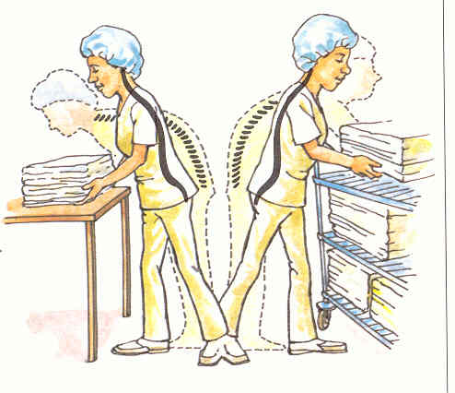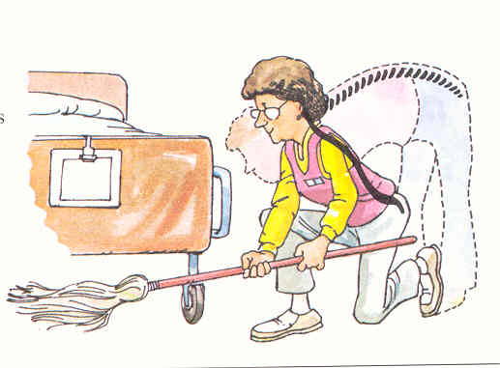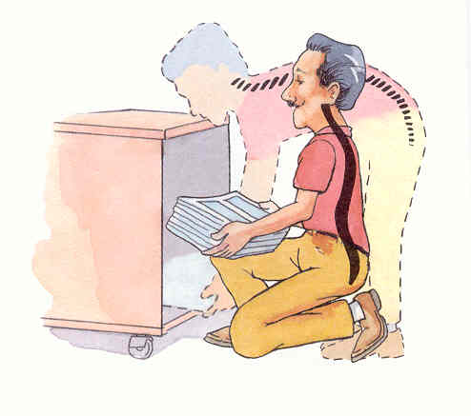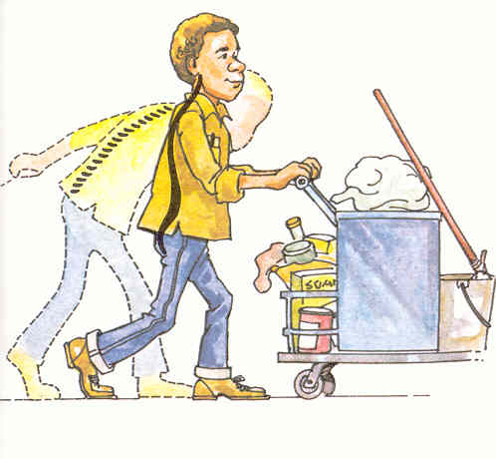**Non-Patient Related Concerns**

**Tips to avoid Injury**

* Keep your back upright while lifting
* Lift steady and smoothly without jerking
* Always ask for help with heavy or light objects
* If you must bend over, do it properly
* Avoid twisting when carrying objects
* Always watch where you are going
* Exercise regularly!!!

**Ergonomic Assessments**   
These are done for you at your worksite. This means fitting the job to the employee and preventing any injuries before they can occur. We do these on a continuing basis.

To request an assessment, call Occupational Health at (404) 785-2228.

**Safety**

**Emergency Numbers**Egleston Campus, Scottish Rite Campus, Hughes Spalding: 5-6161  
The Office Park and Neighborhood Locations: 9-911, then notify Office Park Security at 5-7711 **Emergency Codes & Situations**

**Code Red: Fire or smoke emergency  
  
R _____________ A _____________ C _____________ E _____________**

* In Clinical areas, Respiratory Therapist and/or Engineering identifies and closes medical gas valves as appropriate once Respiratory Therapy verifies it safe to close valves.
* In non-clinical areas, any employee in that area can close the medical gas valves.

**Evacuation:** Examples for the need to evacuate: ***Fire, chemicals, bomb threat, ventilation problems, etc.***

* Evacuation Procedures for the **main hospital** buildings: horizontal first, vertical, and then out-of-the-building if necessary.
* Evacuation Procedures for all other locations (Office Park, Neighborhood Locations, etc.) is out-of-the-building – account for everyone outside of building

**Code Green: Internal or external disaster**

* Internal or external disaster resulting in multiple casualties being treated on an emergency basis.
* Know departmental responsibilities (as applicable)
* Know location of Primary Manpower Pool at the Egleston and Scottish Rite Campuses
* Understanding the HICS structure

**Code Yellow: Bomb threat\bomb emergency**

* Bomb threat or actual bomb emergency
* Remain calm & get all vital information
* Dial Extension 5-6161 (hospitals) or 9-911 (Office Park & Neighborhood Locations) to report information
* Perform a general search of work area
* Do not turn anything “on or off”, or “kick or nudge” anything

**Code Blue: Medical emergency (Cardiac or Respiratory arrest)**

* Main Campus Hospitals, MOB & HSOC 5-6161
* 993 F, 975, Meridian Mark, Office Park and Neighborhood Loc., and all other locations 9-911

**Code Pink: Missing patient situation**

* Call 5-6161 (hospitals) or 9-911(Office Park and Neighborhood Loc.) to report all available information
* Conduct search of your immediate area

**Code Silver: Active shooter/hostage**

* Call 911 with the location of the incident and provide a description of the active shooter(s) and the  
  type of weapon, if known.
* Call the Security Services Department at 5-6161, (Scottish Rite, Egleston and Hughes Spalding locations); 5-7711, (Park and Neighborhood locations).
* Evacuate all persons from the affected area, if safe to do so.

**Code White: Winter weather**

**Tornado/Severe Weather Protocol**

* In main hospitals an announcement is made from Security; Security monitors weather radios for inclement weather
* MOB, 993F, 975, Meridian Mark, Office Park, Neighborhood Locations, and all other Children’s locations, designated offices monitor individual weather radios for severe weather information
* *Move all patients, visitors, and staff to designated shelter location per departmental protocol*

**Electrical Power Failure**

* All Red Outlets are for emergency power
* All critical medical equipment should always be plugged into these RED emergency power outlets
* When normal power is lost, there is about a 5 second delay before emergency power is supplied
* Stairwell lighting, exit lights, and partial hallway lighting is provided under emergency power
* Report problems with any electrical outlets to Engineering

**Telecommunication Failure**

* All Communication Failure Phones are labeled - “Communication Failure Telephone”
* Phones inside of elevators are for use in an emergency, and communicate directly to Security
* Report all telecommunication problems to the IS&T Department

**NOTE:** All emergency code announcements inside main hospitals are preceded by 3 “beep tones”  
  
**Hazard Communications (Chemical Safety)**

**All chemicals, in every work area should have:**

* Warning labels (name and hazard)
* Material Safety Data Sheet (MSDS)

***Your responsibility is to:*** Use Personal Protective Equipment (PPE) & Report any chemical spills or exposures to Security immediately

**Material Safety Data Sheets (MSDS):   
Provide detailed information about a chemical and its hazards:**

|  |  |  |
| --- | --- | --- |
| * Chemical Name | * Health and Hazard Data | * Personal Protective Equipment |
| * Hazardous Ingredients | * Spill or Leak Procedures | * Fire and Explosion Data |

**MSDS’s are required for every chemical in your work area & are** located on ***Careforce Connection***

1. **Click on the Quick Access Tool Drop Down**
2. Click on **Material Safety Data Sheets**

**Environment of Care Policies & Procedures**

* Environment of Care (Safety) policies are located on the Careforce Connection and/or in the House Supervisor’s Office.
* Each department should have procedures addressing general fire & evacuation requirements *and* any specific safety requirements for that department

**Your Role**

* Understand it is the responsibility of every Children’s employee to maintain a safe environment.
* Report items such as water leaks, electrical outages, and other unsafe situations to the appropriate departments for repair.
* Understand Children’s policies and procedures.
* Know how to safely and effectively perform your job responsibilities.
* If you don’t know, ASK YOUR SUPERVISOR

***A safe environment at Children’s is directly related to how much we care and the actions that we take!***

**Security**

**Purpose:** To establish and provide a security program that ensures the care, welfare, safety and security of patients, visitors and staff.

|  |  |  |  |  |  |
| --- | --- | --- | --- | --- | --- |
| **Contacts** | | |  | **Overview of Services Provided** | |
| **Location** | **Emergency** | **Non-Emergency** |  | I.D. Badges | Escort Service |
| Egleston | x5-6161 | 404.785.6142 |  | Vehicle Registration | Staff Training |
| Scottish Rite | x5-6161 | 404.785.2073 |  | Motorist Assistance | Lost & Found |
| HSOC | x5-6161 | 404.785.6811 |  | Parking Management | Financial Deposits |
| The Park | x5-7711 | 404.785.7711 |  | Key & Lock Changes | Internal Investigations |
| Neighborhood Locations | x5-7711  (9-1-1) | 404.785.7711 |  | Shuttle Services | Emergency/Code Response |
| Marcus Autism Center | X5-7711  (9-1-1) | 404.785.7711 |  | I.D. Badges | Escort Service |

**Security Awareness – Two Main Concerns**

|  |  |  |  |  |  |
| --- | --- | --- | --- | --- | --- |
| **Petty Thefts** | | |  | **Domestic Disturbances** | |
| Secure Valuables | Lock Office Doors | Report Suspicious Persons |  | Call Security | CPI Training |

**Workplace Violence**

* Workplace violence is a major concern with security managers and organizations worldwide.
* #1 killer of women at work
* 3rd leading cause of all deaths at work
* 1 in 6 violent crimes occur at work
* More assaults occur in healthcare and social services than any other workplace
* 2/3 of all non-fatal assaults are healthcare related

*\*Emergency Departments *Terminations *Domestic Violence***Signs of someone who may act out**

* History of paranoia, irrational behavior
* Expresses admiration for someone who took matters into their own hands by acting out
* Tends to hold a grudge
* Has severe personal problems
* History of disciplinary problems or grievances
* Sudden interest in weapons
* Sudden change in behavior/dress

**What should you do...?**

* Call Security immediately
* Provide all available information
* If situation escalates into an emergency: **Call 5-6161 or (9) 9-1-1**

**Parking: The Basics**

**Rule #1:** Register your vehicle with security  
**Rule #2:** Park in compliance with all parking rules and regulations  
**Rule #3:** Parking violations will not be tolerated

**Parking: Scottish Rite/Egleston**

* Use ID badge to enter parking deck.
* Parking decal required. Parking deck patrolled by security.
* Shuttle service available to main entrance.
* Valet parking available at the Main entrance and the Emergency Dept. for visitors.
* Parking violations may result in a **$20.00 fine**

**Parking: Scottish Rite** (Use employee entrance for parking garage)

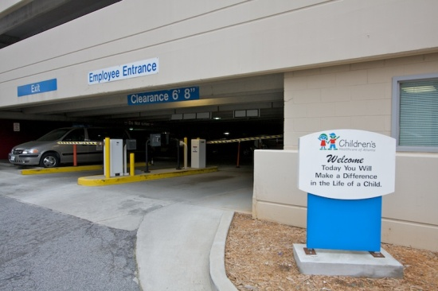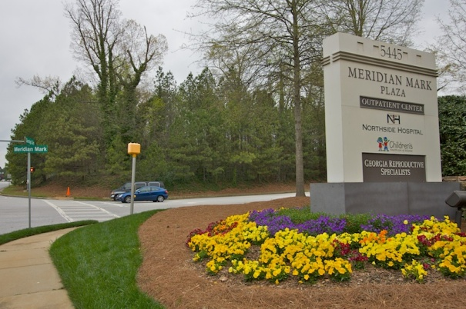

**Parking Egleston:**

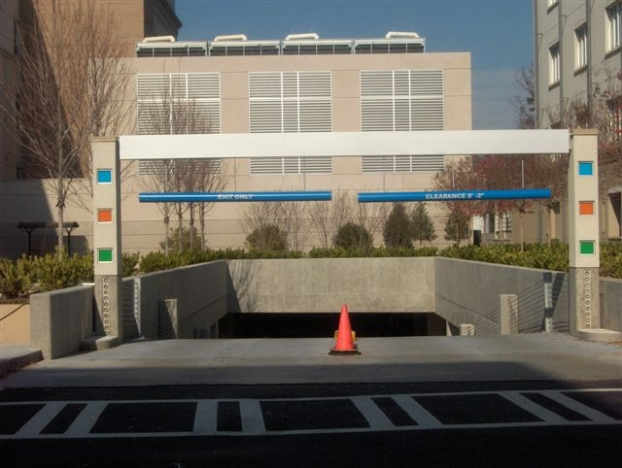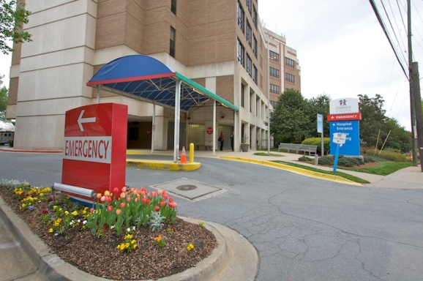Tower 1: Tower 2:

**Parking Deck Security**

* 24 Hour/7 Day Coverage
* Security Patrols / Panic Alarms / Emergency Telephones / CCTV

**Parking: Other Locations**Children’s at The Park & Neighborhood locations = Open Parking

**HSOC**Please register your vehicle in the Security office at HSOC; they will provide further information about parking location and policies.

**Remember:** Be alert, always wear your I.D. Badge, report suspicious persons, protect & secure your valuables, lock office doors after hours… security is ***Everyone’s* r**esponsibility!

**Recognition of Child Maltreatment**

**What is child maltreatment?** Child maltreatment is a general term used to describe all forms of child abuse and neglect. Common types of child maltreatment are: **Physical abuse, Sexual Abuse, Sexual Exploitation, Emotional Abuse and Neglect**

**1. Physical Abuse-** deliberate and intentional injury to a child by a parent or caretaker that results in injuries such as:

* Unexplained bruises, cuts or welts that are in multiple stages of healing or resemble objects
* Burns that have a uniform depth of burn, distinct borders, or are in unlikely areas such as soles of the feet or buttocks
* Bites, human bites are more likely to cause bruising rather than severely torn flesh resulting from animal bites
* Fractures, particularly fractures in infants under 1 year of age; head trauma

**Potential Indicators of physical abuse also include:**

* History provided for the injury changes over time and/or between caregivers or practioners
* Injuries occur in unusual locations for accidental trauma (such as soft parts of the body- stomach, cheeks or buttocks)
* Delay in seeking medical attention or prior suspicious injuries

**2. Sexual Abuse-** an adult or older or more powerful childengaging or coercing a child into sexual acts, which may include:

* Contact with clothed or unclothed genitals, buttocks or breasts for sexual stimulation or gratification; any form of sexual intercourse
* Exhibition of genitals, masturbating in front of a child, or forcing a child to masturbate in front of adult or older child

**Potential Indicators of sexual abuse also include:**

|  |  |
| --- | --- |
| Physical signs | Emotional or behavioral signs |
| * Pain, itching, bleeding, sores, lesions or discharge in   anogenital region   * Stomach aches, headaches, or other   psychosomatic ailments   * Sexually Transmitted Infections * Pregnancy   *These indicators may not be present at all | * Knowledge and interest in sex beyond developmental level * Acting out sexual behavior with self, others or toys * Excessive masturbation that cannot be redirected, or with objects * Changes in eating habits or school performance; sleep problems * Mood swings, withdrawal, depression, self-harm, alcohol/drug use * Regressive behavior- bedwetting, thumb sucking or baby talk after previously outgrowing those behaviors |

**3. Commercial Sexual Exploitation of Children (CSEC)-** Sexual Activity involving a child in exchange for something of value (money or objects), or promise thereof (a perceived protector, or safe place to stay) to the child or another person(s). A victim is a young person (under 18) who has been sexually used, coerced, manipulated, and violently controlled for another person’s profit.

**Potential Indicators of Commercial Sexual Exploitation include:**

* Child accompanied by a dominating, older, nonrelated adult (male or female). The adult may insist on speaking for the child, and the child may act fearful or submissive toward the adult
* Child may not make eye contact with you and/or be hostile or fearful of medical providers
* May possess expensive items, such as: cell phone, jewelry or other electronics
* Child may not be able to present I.D., and/or has changing information on name, age, living situation
* Has older friends and/or “boyfriend”
* May have gang signs/affiliation
* Physical signs, such as: unexplained bruises or scars, cigarette burns, tattoos of someone’s name or nickname
* History of 1+ of: experiencing abuse, DFCS involvement, running away, truancy, pregnancy/abortion/miscarriage

**4. Emotional Abuse-** behavior that results in psychological harm to a child such as:

* Verbal harassment or abuse
* Shaming, name calling, belittling
* Withholding love or attention
* Threatening, intimidating or placing unreasonable demands on a child

**5.Neglect-** failure of the parent or caretaker to provide for a child’s basic physical, emotional or educational needs, or to protect a child from harm or potential harm.

|  |  |
| --- | --- |
| **Potential Indicators of Neglect** | |
| * Repeated ED visits for injuries * Child dressed inadequately for the weather * Unclean, foul-smelling child * Frequently hungry, malnourished child * Child ages 6-16 & not enrolled in school | * Poor supervision, often left home alone * Untreated medical conditions or developmental delays * Noncompliance with treatment recommendation * Lack of immunizations (without medical reason) |

**What can be assumed about those who abuse children? Nothing!** An abuser can be:

* Male or female; any age, race, or ethnicity
* A biological parent, stepparent, partner of parent, other relative, child care provider, coach, friend or neighbor, etc
* Abusers often seek out employment or volunteer opportunities that allow them to work with children -  
   **do not** assume that just because someone works with children that they are safe!

**What is Mandated Reporting?**

* Georgia law (O.C.G.A. § 19-7-5) requires professionals and volunteers that work in child serving organizations to report reasonable suspicions of child abuse or maltreatment to the appropriate authorities
* According to the GA statute **ALL Children’s employees and volunteers** are mandated reporters
* CHOA Policy requires that all employees and volunteers who suspect abuse must make a report
* As long as your report is made in good faith, the reporter is immune from civil or criminal liability
* The knowing and willful failure to make a report is a crime- you can be found guilty of a misdemeanor

**How is a report made at Children’s?**

* Any employee who has cause to suspect abuse should immediately contact a Children’s social worker
* An employee who ensures a timely report is made to social worker shall be deemed fully compliant with the law
* **All employees should review the Child Abuse Management 2.25 policy**

**What about Domestic/Intimate Partner Violence?**

* Exposure to a violent environment can be considered child maltreatment
* Children in homes where domestic/intimate partner violence is present are at higher risk for experiencing abuse
* If you are concerned about DV/IPV, contact the social work department

**What else can be done?** *All* adults share responsibility for ensuring the safety of children. If you see a child being abused:

* Start a non-threatening conversation with the adult who is with the child; or offer to help
* If the child is in danger or left alone stay by the child until the parent returns
* Call Security and/or law enforcement for help
* Call the Prevention & Education team for to ask questions if you are unsure, or to learn more about abuse prevention

**Stephanie V. Blank Center for Safe and Healthy Children-** One center, two clinic locations

Clinic- Scottish Rite Medical Office Building 404-785-3820

Clinic- Hughes Spalding 404-785-9930

Office Park- Prevention & Education 404-785-5004

**Compliance**

**Purpose of Children’s Compliance Program**

To foster and promote a culture that continually *strives for excellence* by the promotion, prevention, detection and resolution of Compliance issues.

**What an effective program does**

* Prevents and detects violations of law
* Can mean the difference between a simple mistake and fraud
* Creates a mechanism to prevent future problems
* May reduce penalties or fines
* It is the best way to protect an organization from fraud investigations

**Common Types of Fraud**

Unnecessary medical procedures, billing for a more expensive service than was actually performed, treatment by non-licensed individuals, duplicate claims, billing for services not rendered, Upcoding

**What we do to detect and prevent Fraud and Abuse**

|  |  |  |  |
| --- | --- | --- | --- |
| * Corporate Compliance Program | * Auditing and Monitoring | * Compliance Connection Hotline | * Policies and Procedures |
| * Investigation Process | * Background Checks | * On-Line Reporting | * Compliance Training |

|  |  |  |
| --- | --- | --- |
| **Standards of Conduct** | | |
| Quality of Care | Conflicts of Interest | Non-Retaliation Policy |
| Compliance with laws and regulations | Employee Responsibility | Compliance Reporting |
| Billing and Coding | Health and Safety | Physician Responsibility |
| Protection of Property | Human Resources | Physician Contracting |

***Who could you talk to about a serious problem?***

Your supervisor? Human Resources? Another supervisor? Do you need to go to another level of responsibility?

**Reporting Procedures**

1. Report any concerns to your supervisor, if possible, but if you can’t do that…
2. Call the Compliance Office directly, but if you want to be anonymous…
3. Call the Compliance Connection line or report online:

**1.877.373.0126 or Go to** [**http://choa.alertline.com**](http://choa.alertline.com)

**Online Compliance Reporting**

* You may disclose your identity or choose to remain anonymous
* You may save your report and return for further communication regarding your concern
* Your computer’s IP address is not recorded
* An opportunity to provide thorough details

**Non-Retaliation Policy**

“No disciplinary action or other form of retaliation shall be taken against any employee for reporting an issue, problem, concern or violation to management, Human Resources, the Compliance Office, the Chief Compliance Officer, the Compliance Connection Line, or online at <http://choa.alertline.com>.”

* Concerns about Safety or Quality of Care?
* Staff & consumers are encouraged to *first* notify the Patient Representative or Nursing Supervisor on your campus.
* If unable to resolve at this level, staff and consumers may contact The Joint Commission ([**http://jointcommission.org**](http://jointcommission.org/)) or the Georgia Dept. of HR, Office of Regulatory Services (<http://www2.state.ga.us/departments/dhr/ors/>)
* *No retaliation or disciplinary action will be taken against an employee for reporting.*
* Any person who has knowledge of or, in good faith, suspects any wrongdoing in the documenting, coding, or billing for services, equipment, or supplies should report it internally so that an investigation can be conducted and appropriate action taken. Retaliation or reprisal against anyone for such a report is strictly prohibited.
* Note: The government grants employees the right to report in good faith, concerns of fraud and abuse to the federal government. Employees who report directly to the federal or state government are also protected under the non-retaliation policy, provided that the employee’s actions don’t create a non-compliant situation or event.

|  |  |  |  |
| --- | --- | --- | --- |
| **Compliance Policies & Laws** | | | |
| * EMTALA | * Stark Law | * False Claims Act | * Fraud & Abuse |
| * HIPAA | * Conflict of Interest | * Non-Retaliation | * Deficit Reduction Act of 2005 (DRA) |

**People to Know**

**Chief Compliance Officer:**  Beth Howell - 404.785.7526 & **Privacy Officer:** Angie Posvech - 404.785.6324

**What if we are not compliant?**

Repayment of dollars, fines to the organization, criminal charges, tarnished reputation, loss of government funding

**H.I.P.A.A.**

**Health Insurance Portability & Accountability Act**

* HIPAA was put into effect on April 14,2003
* Why: To protect the privacy of healthcare information
* Key Concept: Protected Health Information
* name, address, etc.
* other identifying information (e.g. Phone #, account #, etc.)
* any medical information (unless separated from identifying information)
* Treat PHI like you would treat your own personal credit card information

**Beware of transmitting methods of PHI**

* Verbal: talk in private
* Phone: verify identity
* Fax: caution - verify number
* Hardcopy: shred unneeded copies
* E-mail: caution; blind copy retained
* Computer: logoff when done, do not share your passwords

**How else to ensure that you are HIPAA compliant?**

* Computer-based training
* Department-specific training
* Read the Privacy Notice and know the patient’s 5 rights for their PHI: to amend; to view or copy; to restrict access; to restrict mode of communication; and to obtain an accounting of disclosures
* Visit Careforce\Departments\HIPAA

Report privacy concerns to Privacy Officer

**Human Resources**

|  |  |  |
| --- | --- | --- |
| **Campus HR Professionals** | | |
| Amaris Landis | VP of Human Resources (All campuses) | 404.785.7070 |
| **The Park** |  |  |
| Mamie Hodnett | Director of Human Resources | 404.785.7168 |
| David Patrick | HR Manager | 404.785.7784 |
| **Marcus Autism Center** | | |
| Edwidge Ulysse | HR Manager | 404.785.0458 |
| **Hughes Spalding** |  |  |
| Gaytria Thomas | HR Generalist | 404.785.6800 |
| **Children’s Egleston** | | |
| Pat Wagner | Director of Human Resources | 404.785.6235 |
| Edwidge Ulysse | HR Manager | 404.785.0458 |
|  |  |  |
| **Physician Practices** |  |  |
| Michelle Reid | Director of Human Resources | 404.785.7883 |
| **Children’s Scottish Rite, Neighborhood Locations** | | |
| Virginia Means | Director of Human Resources | 404.785.2027 |
| Michael Landis | HR Manager | 404.785.6975 |
|  |  |  |

**How to Locate Policies on Careforce**

* Go to Careforce – Intranet
* Click on policies – upper right hand corner.
* Note: HR - Employment policies typically start in the 4.00 series.

**Below is a list of a few of the frequently used HR policies. Please visit Careforce for a full list.**

* Introductory Period – 4.12
* Corrective Action - There are 2 paths of corrective action:

1. Performance/Behavior – 4.05
2. Attendance/Punctuality – 4.00

* Time Call Procedure – 4.52
* Work Appearance – 4.11
* Electronic Communications – 4.06
* Electronic Device – 4.49
* Social Media and Social Networking – 5.54
* Harassment – 4.22

**What if I experience Harassment?**

* Ask person to stop the behavior; alert management.
* Management will partner with HR to investigate, stop the harassment, and complete investigation quickly.
* Managers/Supervisors must address all complaints.

|  |  |  |
| --- | --- | --- |
| **Performance Management Process** | | |
| **Steps** | **Objectives** | **When** |
| Performance Planning | Establish Goals & Objectives  Create Development Plans  Identify Competencies | Beginning of year or starting new role |
| Development, Feedback & Coaching | Provide Formal & Informal Feedback | Ongoing, throughout the year |
| Performance Assessment | Measure Results Against Established Goals  Assess Competencies and Areas for Improvement | End of the year |

**Service Excellence**

**Customer Service Vision Statement:** To have an experience at Children’s that is ***Seamless, Consistent and Special***

**What does Seamless, Consistent, and Special mean to our customers (external and internal)?**

|  |  |
| --- | --- |
| **Patient / Family** | **Internal Customers** |
| * Doing it the same way every time * Exhibiting courtesy * Avoiding needless waits or feeling helpless * Listening carefully * Treating them like family | * Being Courteous * Responding to requests * Sharing of information * Rewarding and recognizing * Working well together |

**Service Behaviors**

* **Smile and Greet**
* Look patients, families, other guests and other employees in the eye and smile
* Always say “Good Morning” (or Afternoon / Evening)
* Use this chance to assess their status… Do they look lost, confused or angry?
* Also, smile while on the phone; people can "hear" it in your voice.
* **Own**
* Introduce yourself
* Anticipate needs, Listen, Inform, Follow through
* **Thank**
* Always say “thank you” during or after detailed interactions with patients/families and customers:
* Thank you for entrusting us with the care of your child.
* Thank you for taking the time to listen to my explanation of this procedure.
* Thank you. Is there anything else I can do for you?”
* If a customer should say thank you at any point during an interaction, say “my pleasure”.

**What We Remember from a Conversation:** ____% Tone ____ % Body Language ____ % Words

Service Recovery means:

LEAD the Customer to Satisfaction

**Listen:** *Let them vent. Don’t interrupt and don’t do other activities. Then ask questions to understand.*

* Maintain eye contact and nod your head , make sure they do the majority of the talking initially
* Ask clarifying questions to identify the specific issue
  + *“What day were you here last week?” or “Whom did you speak with in the office?”*
  + Avoid saying: *“Calm down…You are mistaken…You don’t understand…You will have to…We don’t…”*
* End with a statement confirming your understanding of your issue.

**Empathize:** *with their situation.*   
*Acknowledge they are upset and apologize. Do not make excuses or get defensive.*

* Tell the customer that you empathize (NOT sympathize) with them (e.g., *"I imagine your child is hungry…"*).
* Selectively agree with what they say. Just because you may disagree with some/many of their points, it's good to show you agree with some of what they say (e.g., *"Yes, that is a long wait."*).
* Apologize even if it’s not your fault – it says you wish they had a better experience

**Act** *on the problem, but ask the customer to choose from alternative solutions.*

* Take ownership of the problem and solve it quickly, even if you can't solve the problem without bringing in a supervisor, take it upon yourself to professionally respond using LEAD.
* Giving options decreases their feeling of being powerless

**Deliver** *on your promises and deliver a “Thanks.”*

* Follow-up with the customer later to confirm their satisfaction with the solution. If appropriate, thank them for bringing this to your attention.

**Total Rewards: Worklife**

|  |  |  |  |
| --- | --- | --- | --- |
| **Family and Dependent Care** | **Wellness** | **Convenience** | **Work Place**  **Support** |

**Family and Dependent Care**

* **Childcare Centers:** New Generations, The Clifton School and The Clifton School at Clairmont
* **Childcare Credit:** $40 credit each pay period
* **Backup Care Options:**
  + Assistance provided for all employees seeking temporary care for infants through the elderly.
  + 80 hours per calendar year
* **Sitter City**
* **Baby Showers**
* **Adoption Assistance**
* **Infertility Assistance**

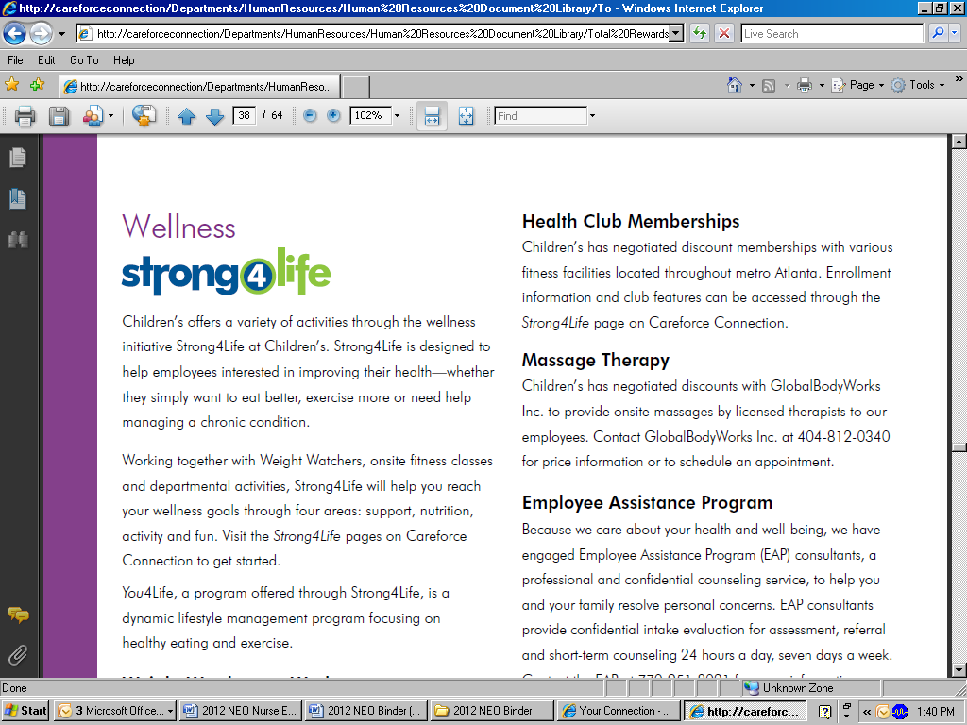

**Wellness**

* **Strong4Life:** Program designed to help employees interested in improving their health – whether they simply want to eat better, exercise more or need help managing a chronic condition.
* **Massage Therapy:** Contact GlobalBodyWorks Inc. at 404.812.0340 for onsite massages.
* **Employee Assistance Program:** (EAP) provides professional and confidential counseling service for you and your eligible dependents. Consultants available 24/7 at 770.951.8021.

**Convenience**

* **Concierge Service:** At Your Service concierge… think of it as your very own personal assistant.
* **Commute Alternatives:** Programs include subsidized monthly MARTA passes.

**Work Place Support**

* **Educational Assistance:** Employees may receive up to $5,000 depending on the course of study.
* **Auto & Homeowner Insurance:** MetPay Plan is a personal property insurance program designed for you to obtain auto, homeowner and other types of insurance at group discounted rates.

**Your Recognition**

* **Celebrations:** Through Celebrations you can recognize a coworker or be recognized by your manager.

**At Your Service**

**What is the At Your Service onsite schedule?**

|  |  |
| --- | --- |
| **Children’s at Scottish Rite** | Mondays: 7 a .m. – 4 p.m. **(lunch 1 p.m. - 2 p.m.)** Tuesdays: 7 a.m. – 11 a.m. Wednesdays: 7 a.m. – 11 a.m. Thursdays: 7 a.m. – 4 p.m. **(lunch 1 p.m. - 2 p.m.)** Fridays: 7 a .m. – 4 p.m. **(lunch 1 p.m. - 2 p.m.)** |
| **Children’s at Egleston** | Mondays: 7 a .m. – 4 p.m. **(lunch 1 p.m. - 2 p.m.)** Wednesdays: 7 a.m. – 4 p.m. **(lunch 1 p.m. - 2 p.m.)** Thursdays: 7 a.m. – 11 a.m. Fridays: 1 p.m. – 4 p.m. |
| **The Park** | Tuesdays:  7 a.m. – 11 a.m. Thursdays: 1 p.m. – 4 p.m. Fridays: 7 a.m. – 11 a.m. |
| **Children’s at Hughes Spalding** | Tuesdays: 1 p.m. – 4 p.m. Wednesdays: 1 p.m. – 4 p.m. |
| **Marcus Autism Center** | Tuesdays: 1 p.m. – 4 p.m. |

At Your Service representatives are onsite at Children's during the following hours (times are subject to change without prior notice)

**Price List**

**Gift Cards Tickets**

**Stores Atlanta CityPass** Adult: $59.00

Macy’s $50, $25 Child: $44.00 (3-12)

Wal-Mart $100, $50, $20, $10

Home Depot $50, $20, $10 **Georgia Aquarium** Adult: $30

Target $50, $20, $10 Child: $24 (ages 3-12)

Senior: $25

**Miscellaneous**

BP Gas $25 **Stone Mountain**

Spa Wish $50One day park Pass: $21 (3 & up)

**Restaurants.com $5 ($25 value)** Adult Annual Membership $51 (12 & up)

Child Annual Membership $41 (3-11)

**Restaurants**

Chili’s $25 **Zoo Atlanta** Adult: $15.00

Olive Garden / Red Lobster $25 Child: $12.00(3-11)

Outback $50

Ruby Tuesday $25 **Biltmore Estates** Adult: $40

Starbucks $10 Youth: $20 (10-16)

**Xpress Pass** Green$25  **Six Flags** One day ticket: $33.00

Blue $35 Season Pass: $60.00

Meal Ticket: $11.00

**MARTA** **White Water** One day ticket: $27.00

**Monthly $51.30** Season Pass: $50.00

**10-Ride Pass $25.00** Meal Ticket: $11.00

Dual Park Annual Pass $99.00

**Movies**

Regal Cinema $7.50 – unrestricted $6.50 – restricted$25.00 – movie bundle

AMC $7.50 – unrestricted $6.00 – restricted $24.00 – movie bundle

$3.00 – Drink Show Voucher $3.00 – Popcorn Show Voucher

Highlighted Items can be payroll deducted

**ALL TICKET SALES ARE FINAL – NO EXCEPTION**

**Contact us at:** Sandra Humphries @ ext. 52526, Shakita Braswell @ ext. 52525 or the Call Center @ 404-815-9980

**Prices Subject To Change Without Prior Notice - Effective 08/29/12**

**Technology Training**

|  |  |  |
| --- | --- | --- |
| **How to Log into the Children’s Application Portal** | | |
|  |  | **Double Click the Children’s Application Portal icon** |
|  |  | **Log into Children’s Application Portal** User Name: Employee ID Number  Initial Password: Capital First Initial, Lowercase Last Initial and Full Birth date  Example:  John Smith, July 17, 1977 = **Js07171977**  If you are a traveler or contractor your user ID and password will be: First Initial, Last Initial, and Last 4 of Social |
|  | changeaname | Enter the Old Password and create a New Password.  **NOTE:** The New password:   * **must contain at least 8 characters** * must contain characters from at least three of the following four categories: * uppercase characters (A - Z) * lowercase characters (a - z) * base 10 digits (0 - 9) * non-alphanumeric (For example: !, $, #, or %) * should not contain three or more characters from the user's account name. * should not contain personal information, names of family members, and so on. * cannot contain company name’s (e.g. CHOA, Scottish Rite, Egleston). |
|  | applications2 | If you need to change your password after the initial change click on the gold key to change password.  *(Should you have problems with logging into Epic, please call IS&T at 5-6767)* |

**E-mail Etiquette**

System e-mail standards

**Signatures: (Recommended font: Arial or Times New Roman in 10 point or 12 point)**

Name (first and last with credentials if applicable)  
Children’s Healthcare of Atlanta  
Office e-mail address (first.last@choa.org)  
Office phone #  
Office fax #  
Office pager # (optional)  
Personal cell # (optional)  
Personal pager # (optional)

As a not-for-profit organization, Children's benefits from the generous philanthropic and volunteer support of our community. Visit [www.choa.org/give](http://www.choa.org/give) or call 404-785-GIVE to donate.

**To maintain continuity and professionalism, do not include:**

- Personal Quotes  
- Script or difficult to read fonts (use italics only when necessary)  
- Clip art  
- Wallpaper  
- Personal Web address

**Out of office e-mail response:** Thank you for your e-mail. I will be out of the office from Friday, Oct. 31, to Wednesday, Nov. 5, with limited access to e-mail. I will return your e-mail on Wednesday, Nov. 5. If you need immediate assistance, please call my cell phone at xxx-xxx-xxxx (optional) or contact (contact person) at xxx-xxx-xxxx.

**Telephone Etiquette - System Telephone Standards**

**Telephone Basics - Sample phone message:** “Hello. You have reached the voice mail of [first and last name] in the Children’s Healthcare of Atlanta [your department] department. I am either on the telephone or away from my desk. Leave your name, number and a brief message, and I will return your call as soon as possible. Thank you, and have a great day.” *\*Include cell phone number if applicable.*

**Example of an appropriate “away from the phone” message:** Hello. You have reached the voice mail of Evelyn Walker. I will be out of the office from Friday, Oct. 31, until Wednesday, Nov. 5, with limited access to voice mail. If you need immediate assistance, please contact Mary Anna McAulliffe at 404-123-4567, otherwise I will return your call when I get back to the office Nov. 5. Thank you, and have a wonderful day.

**Answering the phone example:** “Thank you for calling Children’s Healthcare of Atlanta at (location) (service specialty). This is (your name). How may I help you?”

**Putting a caller on hold:** Ask for permission and wait for a response before putting a caller on hold.

**Transferring calls:  
1.** During a call, press the TRANSF soft key. (Caller will be placed on hold).  
**2.** Dial the extension (5####) to which you want to transfer the call.   
**3.** Press TRANSF now, or wait for the recipient to answer and announce the call.

*If you make a mistake, press the LINE key of the original call.*

**Solution Center  
1.** Help Desk  
**2.** 24/7  
**3.** 404.78**5.6767**

**Technology Training**

Windows Computer Skills Assessment

*Instructions for Completing the Windows Computer Skills Assessment in Aspen-TotalLMS*

*The Windows Computer Skills Assessment is a computer-based assessment (CBA), designed by the Technical Training Team, to determine one's proficiency in a Windows environment. Once proficiency has been demonstrated in using Windows, then that person is ready to begin Epic Systems training.*

**Important Points:**

1. Due Dates:
   1. Epic Users: This assessment must be completed in Aspen-TotalLMS **before your Epic class starts the following week**.
   2. Non-Epic Users: This assessment must be completed in Aspen-TotalLMS within **60 days of your hire date**.
2. You must score an **80%** or higher to pass. If passing score is not attained and you will be working in Epic, you will be required to complete the Building Basic Computer Skills class which is held the Thursday of New Employee Orientation (NEO) week from 4:00pm to 6:00pm. ***You may not proceed with any Epic direct patient care training without passing this assessment.***
3. Be sure to read each question carefully.
4. You answer the questions by clicking on the screen. Your first click will be counted as your answer. You cannot go back to answer questions.
5. When you are ready to proceed to the next question, click the blue arrow once.

**Beginning the Assessment:**

1. Open Internet Explorer (Careforce Connection home page).
2. 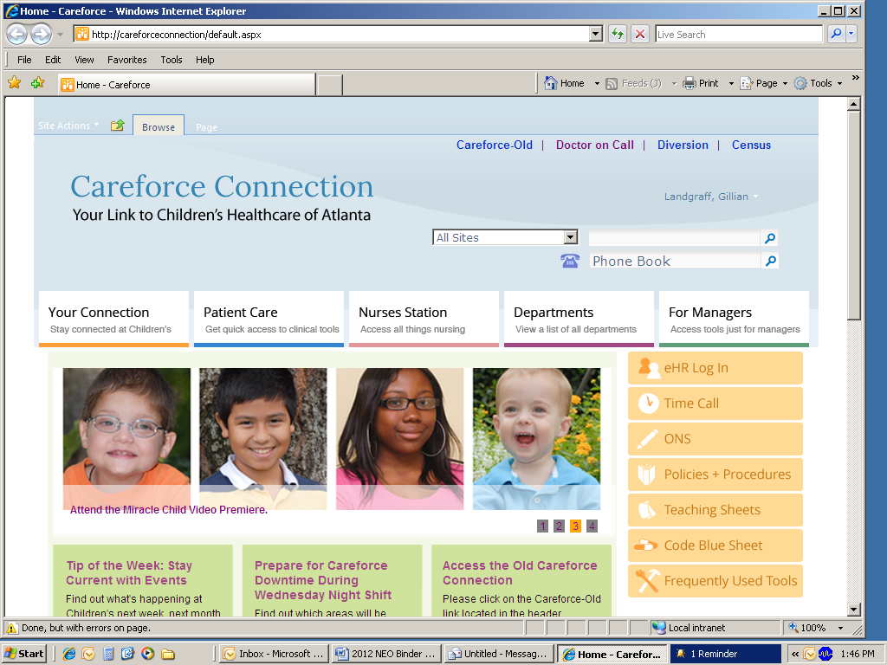In the orange **YOUR CONNECTION** section tab on the main screen, click on Aspen- TotalLMS.

Click on **Your Connection**

1. Click on Aspen-TotalLMS**.**

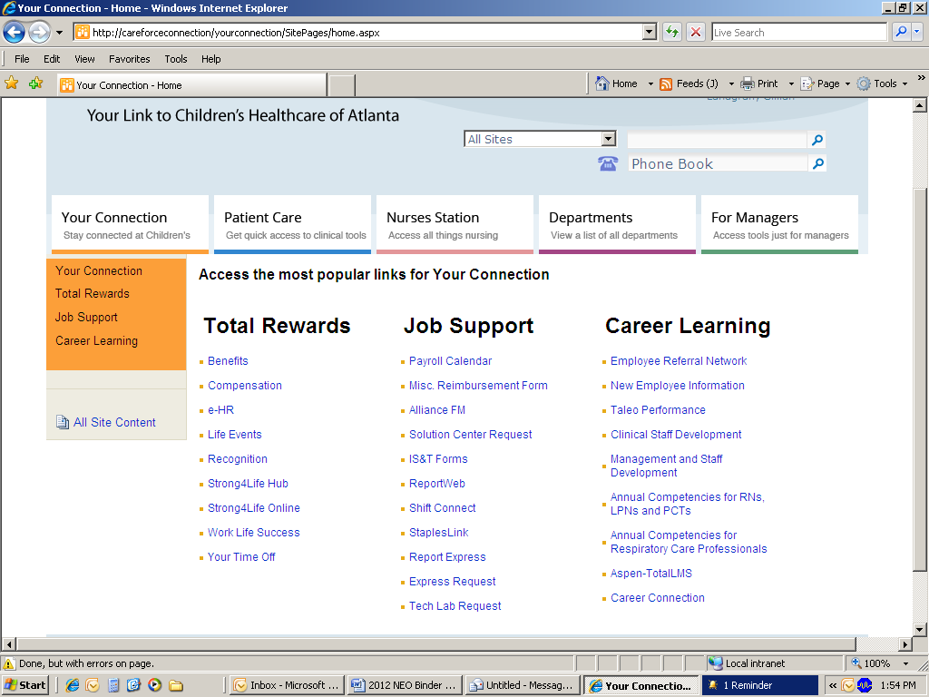

Click on **Aspen-TotalLMS**

1. Login using your **user ID**.
2. Your password will be the word **“training”, and the last 1 digit of your SSN**. (Ex: John Smith (SSN: 123-45-6789) would enter “training9”).
3. You will be prompted to change your password. Be sure you choose a password that you can remember!
4. Under Catalog Search type **new hires** and press <ENTER>.
5. Click **Register** next to the title **Windows Computer Skills Assessment for New Hires**.
6. Scroll down and click **Submit** from the bottom of the screen.
7. In the screen that follows click **Start** to launch the CBT.

**Ending the Assessment:**

1. Once you reach the end of the assessment, you will be prompted to score your quiz. Click the button marked **Score Quiz**, and your score will appear in the box below the score button.
2. Click the **blue arrow** to proceed to the next page and save your score.
3. Click **Save Score**. Your score is now saved in Aspen-TotalLMS and you can exit the system or proceed with another assessment.
4. If you failed to score an **80%** or higher and will be using Epic, you will be required to complete the **Building Basic Computer Skills class** prior to your Epic classes.
5. If you failed to score an 80% or higher and will not be using Epic, your manager will determine if the class will be required. However, the class is open to all Children’s employees. You may choose to take it even if it is not a job requirement.

**Payroll**

**“TIME”:**

A time keeping system which uses the telephone (**Time Call**) and/or computer (**Time Web/Time PC**), rather than a time clock, to capture both Productive and Non-Productive time.

**Entering Time for Orientation:**

|  |
| --- |
| **Phone** |
| 1. Dial x 5-8463 2. Enter your Employee I.D. Number, Press # 3. Enter your PIN number, Press # 4. Press 2 (for Non-productive) 5. Enter date (Example: MMDDYY), Press # 6. Enter pay code = 103, Press # 7. Enter start time = 0830, Press # 8. Enter number of hours = 800, Press # 9. Press # to complete entry = (long chime indicates clocking is recorded) |
| **Computer** |
| 1. Go to Careforce 2. Go to Time 3. Enter your Children’s Network ID and Password 4. Click on “**Login**” 5. From the home page, Select the “**Employee**” button 6. This will bring you to the Employee Time Card Screen (TCS) 7. From the TCS, select “**Add Calendar**” (Employee Favorites section; left pane). Enter Date, Time (08:30) and Pay Code for Orientation (ORN ) 8. Click on “**Save**” 9. Logout |

**Clocking In & Out after Orientation**

**Using the phone (Time Call):**

|  |
| --- |
|  |
| 1. Dial x 5-8463 or 5 - “TIME” 2. Enter your Employee I.D. Number, Press # 3. Enter your PIN number (last 4 digits of your ss#), press # 4. Press 1, Listen for the time 5. Press # *(long chime indicates clocking is recorded)* 6. Hang up |

**Using the computer (TimeWeb/TimePC)**

**Add Clocking using Quick Badge**



* Open Careforce Connection icon on your desktop
* Select **TIME**

Step 2: Select Time Call

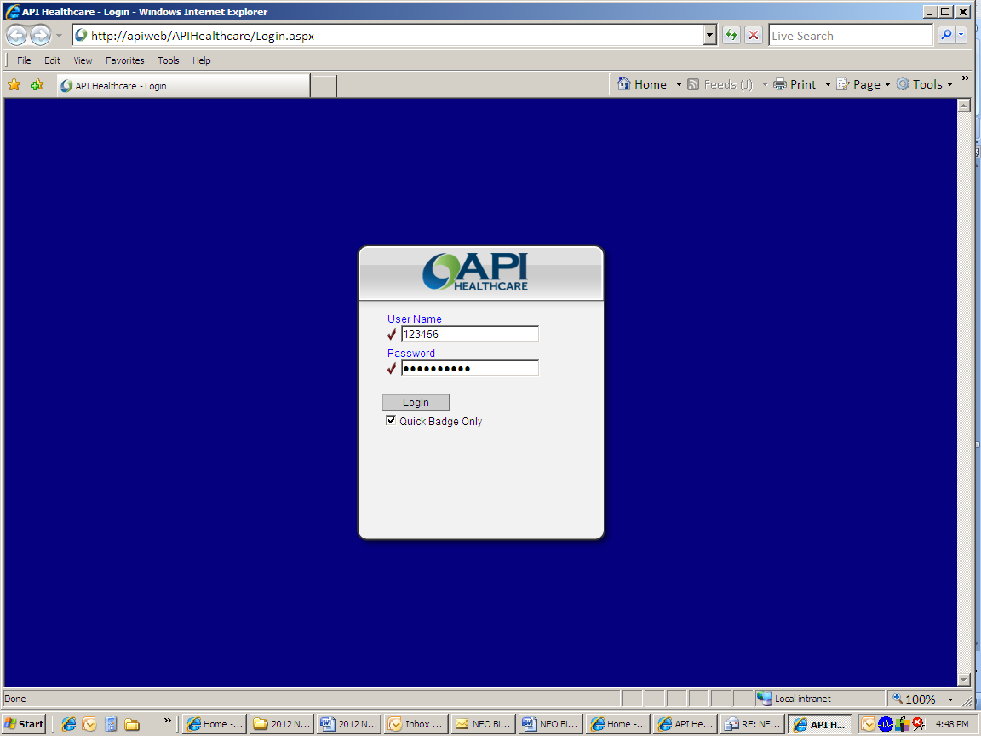

**Step 1:**   
**Type in your network User Name & Password.**

User Name: Your network login   
(default = employee ID number)

Password: (your network password)

**Step 2:** Click in the **Quick Badge Only** box

**Step 3:** Select “**Login**” or press “**Enter**” key.

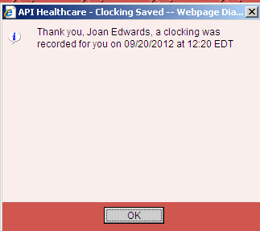

Popup box will appear confirming that you are using quick badge to register time

**Step 4:** Click on ***OK***

Step 2: Select Time Call

**Add Clocking with a special code**

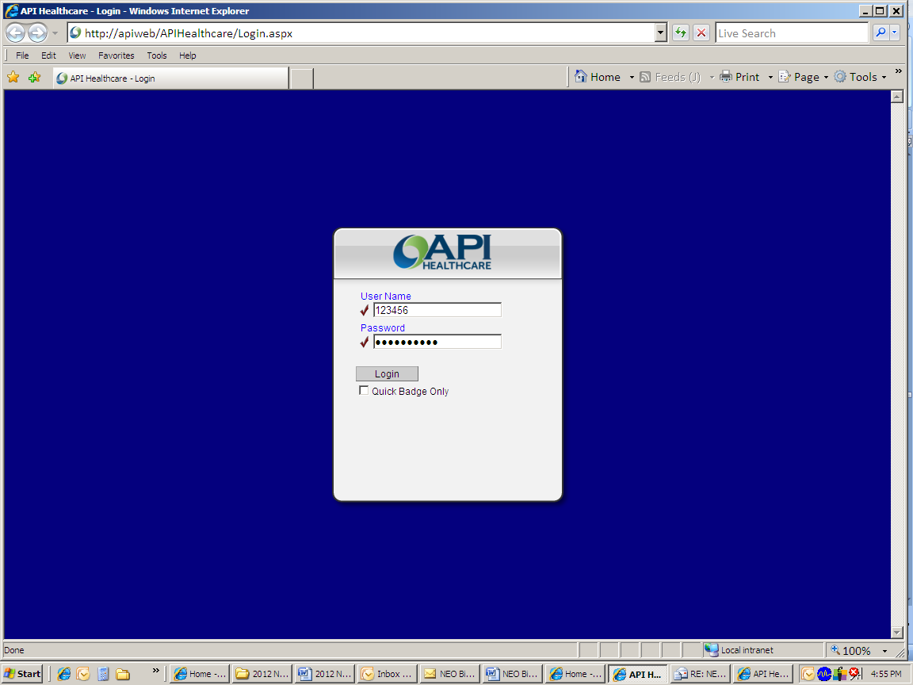

**Step 1:** Type in your Network ID and Password.  
**Step 2:** **DO NOT** click in **Quick Badge Only** box **Step 3:** Click on **Login**

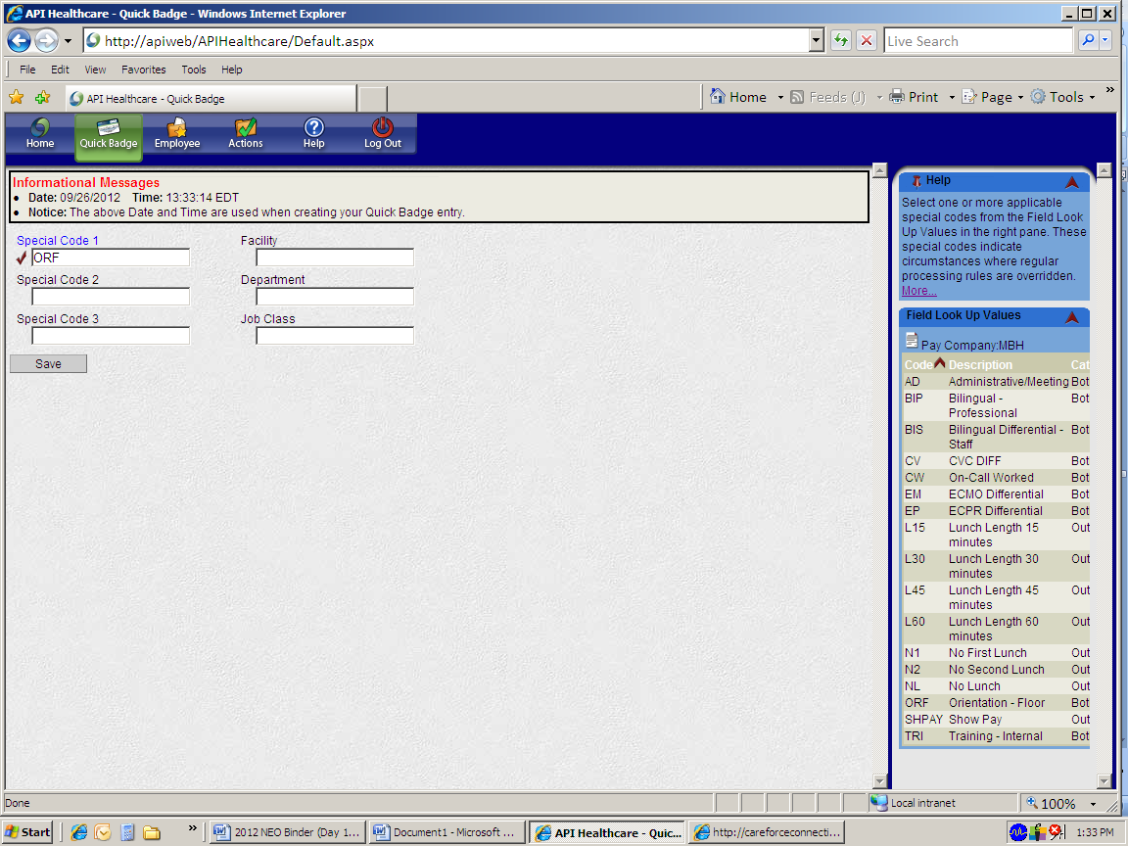

**Step 4:** Click on **Quick Badge**

**Step 5:** Refer to menu in right pane and enter special code (ex. ORF = Orientation Floor)

**Step 6:** Click **Save**

Step 2: Select Time Call

**Add Calendar**

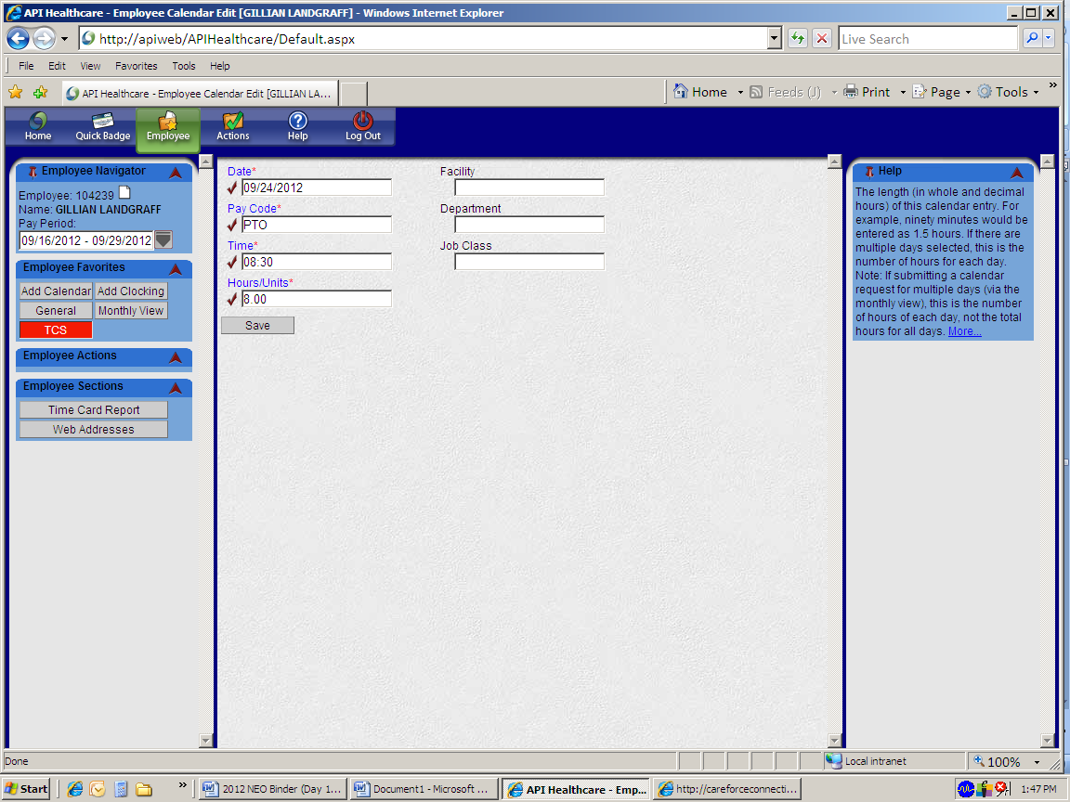

**Steps 1-3:** Repeat Steps 1-3 from previous page  
**Step 4:** Click on the **“Employee”** button from the toolbar.

**Step 5:** Select “**Add Calendar**”

**Step 6:** Enter **Date, Pay Code (ex. PTO), Time** (start time of shift)and **Hours** (number of hours requested per day)

**Step 7:** Click **Save**  
(Note: If your number of hours is not the same for each day you will need to enter each day separately.)

**Time Card Report**

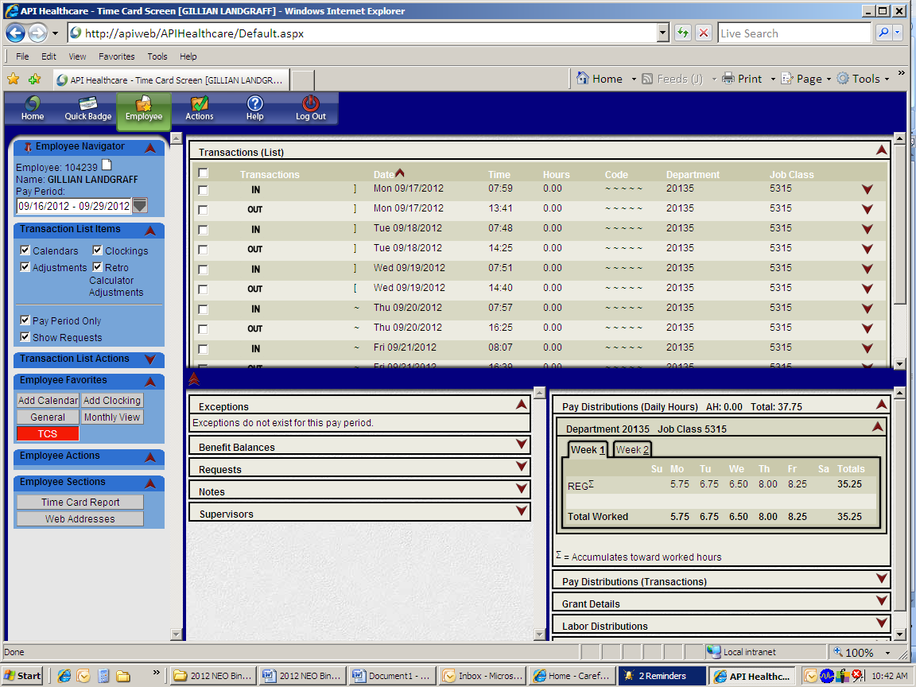

**Steps 1-3:** Repeat Steps 1-3 from previous page Select “**Employee**” from the toolbar. This will bring you to your Time Card Screen (TCS).  
  
**Step 4:** From your TCS, select the pay period you want to look at under Employee Navigator, using the drop down button for pay period. Then select TCR (Time Card Report) under the Employee Section in the left pane.

Jane Smith

123456

**TIME and Attendance Training**

***Instructions for Completing the Required Employee TIME and Attendance Computer Based Training (CBT) modules in Aspen-TotalLMS***

*The TIME CBT for Employees is designed to familiarize employees with our newly, upgraded time and attendance system. After completing the TIME CBT, an employee should have the tools necessary to accurately account for their time and attendance at Children’s.*

**Important Points:**

1. The CBT’s are designed based on the job classification you hold at Children’s (salaried or hourly). Please make sure that you choose the correct CBT for your job classification.
   1. If you are a Salaried employee, please select the CBT with the following course name:

**CBT for Salaried employees:** **TIME-TA CBT XMPT 01: TimePC for exempt (salary) employees**

* 1. If you are an Hourly employee, please select the CBT with the following course name:

**CBT for Hourly employees:** **TIME-TA CBT NXMPT 01: TimePC for Non-exempt (hourly) employees**

1. All modules of the selected CBT must be completed in order to have your transcript marked as “Completed.”

3. You must score an **80%** or higher to pass. If a passing score is not attained you are required to take the CBT again until you have attained a score of 80% or higher.

**Beginning the CBT:**

1. Open Internet Explorer (Careforce Connection home page).
2. In the orange **YOUR CONNECTION** section tab on the main screen, click on Your Connection.

Click on **Your Connection**

**TIME and Attendance Training (Cont.)**

1. Once on the Your Connection screen, click on Aspen-TotalLMS



Click on **Aspen-TotalLMS**

1. Then click on Go To Aspen-TotalLMS to get to the LMS login screen.
2. Login using your **User ID (your 6 digit employee ID number)**.
3. Your password will be the word **“training”, and the last 1 digit of your SSN**. (Ex: John Smith (SSN: 123-45-6789) would enter “training9”).
4. You will be prompted to change your password. Be sure you choose a password that you can remember!
5. Under Catalog Search type **time ta** and press <ENTER>.
6. Click **Register** next to the title of the CBT that you need to take based on your job classification as Salaried or Hourly:

**CBT Title for Salaried employees:**

**TIME-TA CBT XMPT 01: TimePC for exempt (salary) employees**

**OR**

**CBT Title for Hourly employees:**

**TIME-TA CBT NXMPT 01: TimePC for Non-exempt (hourly) employees**

1. Scroll down and click **Submit** from the bottom of the screen.
2. In the screen that follows click **Start** to launch the CBT.
3. Remember, you must complete ALL modules of the CBT and pass the “Challenge” section with a score of **80%** or better in order to receive a “Completed” status on your transcript.

**Payroll FAQ:**

**Is time taken out for lunch?**

Yes, a 30 minute lunch will be deducted from your productive time once you have worked 6.5 hours during a shift. If you do not take a lunch break there is a special code for recording no lunch.

**Can you tell me about “Shift Dif”?**

**Shift Differential Information**

1. Human Resources determine the standard shift differentials for each eligible job classification. Exempt jobs are not eligible for shift differential.
2. Shift differentials are paid in addition to the employee’s base hourly rate.
3. Although individual employee schedules may vary, shift differentials are paid based on the following standard shifts:

1st Shift Day 7:00 AM (0700) - 3:00 PM (1500) - (Note: no shift dif pay for 1st shift)

2nd Shift Evening 3:00 PM (1500) - 11:00 PM (2300)

3rd Shift Night 11:00 PM (2300) - 7:00 AM (0700)

Weekends 11:00 PM (2300) Friday - 7:00 AM (0700) Monday

1. Employees who are eligible for shift differentials are required to work at least **four hours** within the evening, night, or weekend shifts, or any combination of those shifts, in order to receive any shift differential.
2. Employees who are on call or who have been called back to work are not eligible to receive shift differentials.
3. Shift differential is paid only on actual hours worked (excluding call back hours worked). Shift differential is not paid for PTO, Professional, Annual or Bereavement Leave, or On-call hours.

**2013 Payroll Calendar**

|  |  |  |  |
| --- | --- | --- | --- |
| **Pay Period** | **Beginning** | **Ending** | **Pay Date** |
| 1 | 12/23/12 | 01/05/13 | 01/11/13 |
| 2 | 01/06/13 | 01/19/13 | 01/25/13 |
| 3 | 01/20/13 | 02/02/13 | 02/08/13 |
| 4 | 02/03/13 | 02/16/13 | 02/22/13 |
| 5 | 02/17/13 | 03/02/13 | 03/08/13 |
| 6 | 03/03/13 | 03/16/13 | 03/22/13 |
| 7 | 03/17/13 | 03/30/13 | 04/05/13 |
| 8 | 03/31/13 | 04/13/13 | 04/19/13 |
| 9 | 04/14/13 | 04/27/13 | 05/03/13 |
| 10 | 04/28/13 | 05/11/13 | 05/17/13 |
| 11 | 05/12/13 | 05/25/13 | 05/31/13 |
| 12 | 05/26/13 | 06/08/13 | 06/14/13 |
| 13 | 06/09/13 | 06/22/13 | 06/28/13 |
| 14 | 06/23/13 | 07/06/13 | 07/12/13 |
| 15 | 07/07/13 | 07/20/13 | 07/26/13 |
| 16 | 07/21/13 | 08/03/13 | 08/09/13 |
| 17 | 08/04/13 | 08/17/13 | 08/23/13 |
| 18 | 08/18/13 | 08/31/13 | 09/06/13 |
| 19 | 09/01/13 | 09/14/13 | 09/20/13 |
| 20 | 09/15/13 | 09/28/13 | 10/04/13 |
| 21 | 09/29/13 | 10/12/13 | 10/18/13 |
| 22 | 10/13/13 | 10/26/13 | 11/01/13 |
| 23 | 10/27/13 | 11/09/13 | 11/15/13 |
| 24 | 11/10/13 | 11/23/13 | 11/29/13 |
| 25 | 11/24/13 | 12/07/13 | 12/13/13 |
| 26 | 12/08/13 | 12/21/13 | 12/27/13 |

* Paychecks can be viewed confidentially on e-HR, via: [www.choa.org/staff](http://www.choa.org/staff)

**The Foundation**

* Separate legal entity with 30-member Board of Trustees
* Consists of development, marketing, external wellness and government affairs
* Raises over $50 million dollars of support for the hospital annually
* Have over 20,000 volunteers saving Children’s over $1 million dollars annually

**Departments**

|  |  |  |  |
| --- | --- | --- | --- |
| * Major and Planned Gifts | * Children’s Miracle Network | * Sports Network | * FRIENDS |
| * Foundation Relations | * Holiday & Community Events | * Operations | |

**Key Events and Projects**

* Strong Legs Run
* GA/GT Spring Baseball Classic
* News/Talk 750 WSB Radio Care-A-Thon for AFLAC and Blood Disorders
* The Children’s Christmas Parade
* FM Radiothon (Star 94, Dave FM)

**Marketing & Public Relations**Ensure that Children’s Healthcare of Atlanta has a positive image in the community:

* A consistent and strategic presence for Children’s Healthcare of Atlanta locally, regionally and nationally
* A System-wide communication resource for staff, patients and families and the community

|  |  |  |  |
| --- | --- | --- | --- |
| **Public Relations** | **Marketing** | **Creative Services** | **System Marketing** |
| - Pager for any media contact:   404-570-9717  - Editorial services, System  messaging, style guide and fact   sheets | - Clinical business  development  - Fundraising  communications | - WEB and Print collateral pieces | - Advertising  - HR communications design  - Facilities communications  - Advocacy marketing |

**Government Affairs**

* No business is more regulated than a hospital.
* The government controls how many rooms and beds Children’s has, certain qualifications our staff must meet, and in large part how we are paid for our services.
* Works as a “middle man” between Children's and the Georgia General Assembly
* Helps to write bills; speaks before the Assembly
* Helps Children’s obtain:
* Programs and funding
* Licenses
* Certificates of Need
* And assists with other regulatory issues

|  |  |  |  |
| --- | --- | --- | --- |
| **External Wellness** | | | |
| **Healthy Behaviors**   * Nutrition * Physical Activity | **Illness Prevention**   * Immunizations * Hand washing | **Safe Kids (Unintentional Injuries)**   * Traffic Injuries * Drownings * Falls | **Georgia Children’s Health Alliance (GCHA)**   * Healthy Births * Childhood Obesity * Child Abuse & Neglect |
| **Guiding Principles**  Statewide Reach ~ Measurable ~ Sustainable ~ High Impact ~ Leverage ~ Primary Prevention Focus | | | |

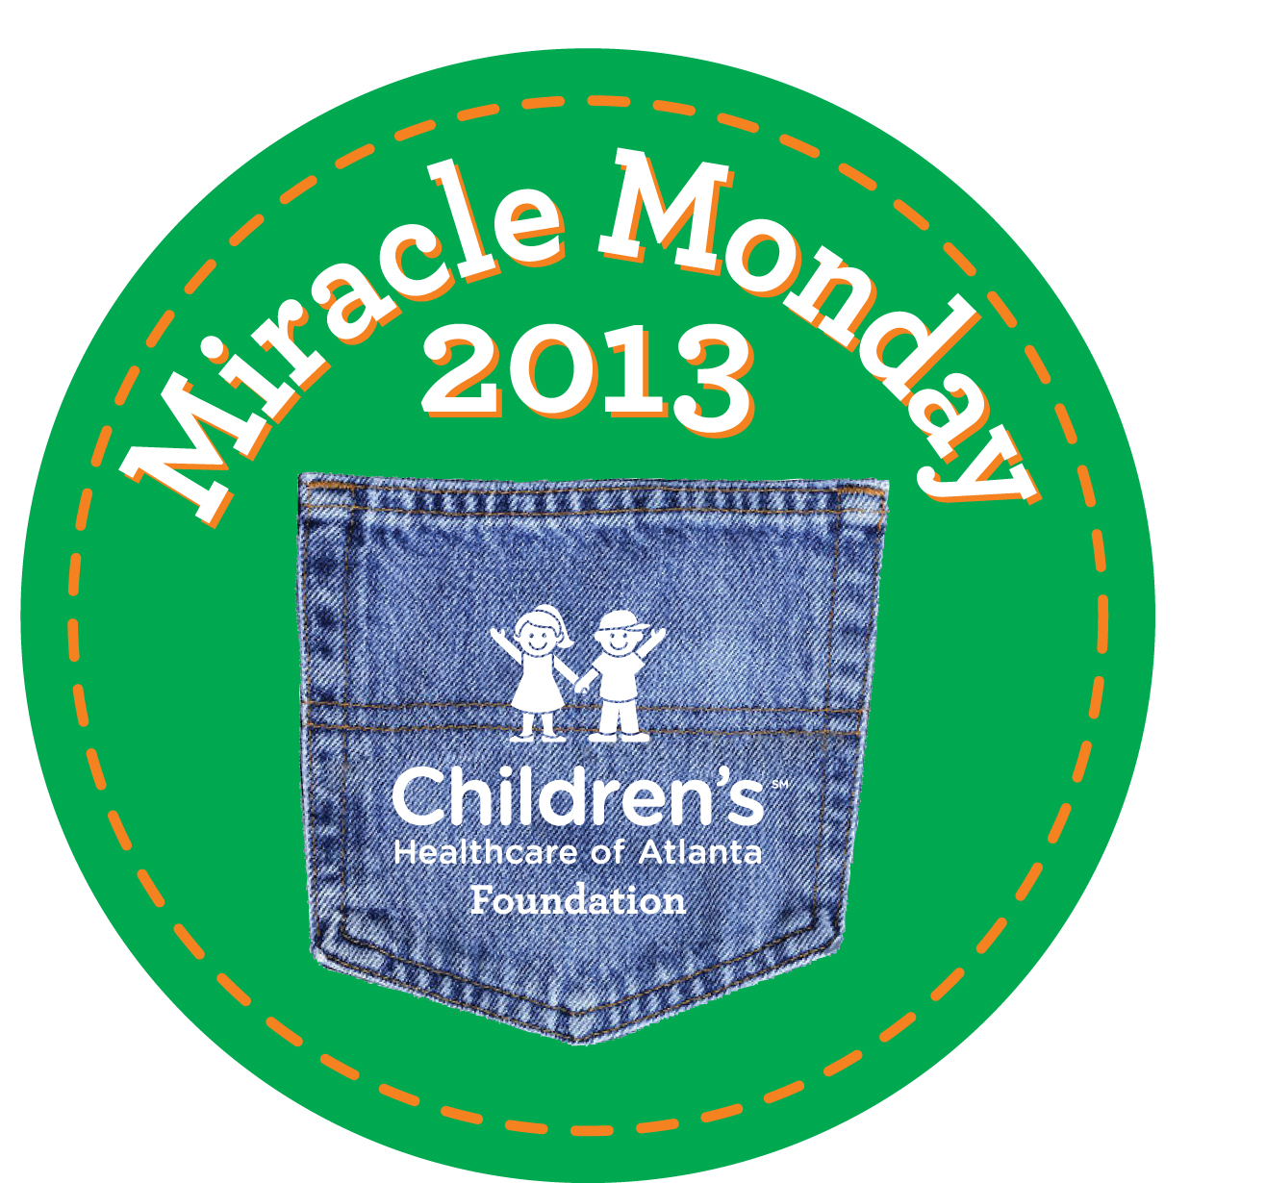***The First Monday of Every Month*** you can wear jeans to work by participating in Miracle Mondays!

Miracle Mondays is a program offered by the Foundation where employees can register through Careforce and **donate $5/month to wear jeans to work**. This year, Miracle Monday will be the first Monday of EVERY MONTH. Check Careforce for some deals in buying stickers for the whole year. This is a great opportunity to mix up the dress code, while supporting our hospitals and giving back to our patients. Please visit the Miracle Mondays page on Careforce Connection for more details or email [miraclemondays@choa.org](mailto:miraclemondays@choa.org) with any questions. Welcome to Children’s!

**Five Reasons To Give To Children’s**

1. Children belong in a children’s hospital
2. Children’s exists to serve the community
3. Children’s is dedicated to advancing pediatric healthcare
4. As a not-for-profit organization, Children’s relies on philanthropic and volunteer support to help provide high quality care to our children.
5. Children’s is committed to spending wisely the gifts we receive.

**Giving is easy…**

* To give now via payroll deduction, log in to [**eHR**](http://lawpkg.choa.org/lawson/portal/).
* Select “Employee Giving” in the left navigation.
* Follow the steps to choose your giving amount.
* Patient Family Referrals – [www.choa.org/thankyou](http://www.choa.org/thankyou)

**For Questions**

Email [EmployeeGiving@choa.org](mailto:EmployeeGiving@choa.org) or call 404-785-GIVE

**Your First Year Connection**

**What is Your First Year Connection?**

* Taleo onboarding web site for new employees
* Houses all your onboarding tasks throughout the year
* Each web site is unique to each employee: Do not share your web site address

**How do I gain access to my website?**

* Obtain the address link in e-mails from human.resources@choa.org
* Your login and password for Taleo are the same as when you applied for your position
* E-mails are sent to your personal e-mail address before you start & are switched to your Children’s account once you start
* If you have not received your pre-start e-mails, check your junk e-mail account

**What will I experience?**

* 10 e-mails throughout your first year
* Each e-mail will inform you that you have new tasks to complete
* Majority of tasks (after pre-start) should take place in meetings with you and your direct supervisor
* Your direct supervisor will also receive tasks/action items throughout the year that will match your onboarding tasks
* Your direct supervisor will be able to track your progress on completing tasks

**What should I do if I cannot log into the web site?**

* If you forgot your password, use the forgotten password link on the web site
* The web site will lock you out of the site if you attempt to enter your password **3** times and it is incorrect. Once this happens you can wait for 30 minutes before re-entering the web site or contact HR Service Center at (404) 785-4747
* If you misplaced your e-mail, contact your recruitment coordinator

**What are some helpful tips?**

* Keep all e-mails
* Set aside time when completing forms, remember you cannot save your work and come back to a form
* Be careful when submitting forms; make sure all information is correct. Once you click submit, you can’t edit the form again

**Important Information**

* For any questions about the web site, please review the user tip sheets and guides located under the New Employee Information page on Careforce at <http://careforce/cms/default.aspx?id=3165>
* Contact HR Service Center at (404) 785-4747 for re-setting passwords

Frequently Asked Questions

**1. I have forgotten my password, what do I do?**Once on the *Login* page, click the *Forgot your password?* link. Follow the instructions to retrieve your password.

**2. I’m trying to complete my tasks on the *Your First Year Connection* Web site, but it keeps freezing up.**There are several things that may cause this problem:

* Your Web browser may not work with the system. Netscape, AOL or Internet Explorer on a MAC will not work.
* Not all Web browsers work with our system, check Web browser to ensure you have: Internet Explorer 7 (recommended).
* Your screen’s resolution is lower than 720 pixels. *The application may work on other systems/browsers, but you may experience intermittent problems.

**3. What if I’m not receiving the *Your First Year Connection* e-mails?** These e-mails may be going into your spam, junk or bulk mail folder. Make sure to identify the address as “Not Spam” to receive them in your inbox.

**4. I’m not very familiar with computers, are there resources for me?**

Yes. A tip sheet and user guide is available in *Your First Connection* under general documents.

**5. How often will I receive e-mails?**

E-mails will be sent at different milestones throughout your first year (e.g., start date, 30 days after start, 60 days after start, etc.). You’ll receive your first three e-mails to your personal e-mail account, then all others to your choa.org e-mail account.

**6. What are some things I should consider when completing tasks?**

• Make sure to set aside an amount of time to complete a form from start to finish. Once you submit, it is complete and final; you cannot re-open the document and make edits.

• You’re not able to save forms; make sure all forms are complete and accurate before submission.

**7. What do I do if I have the incorrect orientation schedule or my orientation schedule is incorrect?**

Contact your Recruitment Coordinator.

**Other Important Information**

**The Medical Libraries of Children’s Healthcare of Atlanta**



All Children’s staff, including Medical Staff, Nurses, Allied Health Professionals, and Students are invited and encouraged to use the Medical Libraries for patient care information, continuing education, and medical research. Services are available to all Children's personnel, regardless of work location. Employees may email, fax, phone, or fill out the [online request form](http://careforce.choa.org/cms/default.aspx?id=1385&formaction=takeit&formid=24&formname=Ask+A+Medical+Librarian).

**Online Searches**: Library staff members will perform searches as requested or instruct users in database searching by appointment or class. See Aspen for the class schedule.

**e-Resources (**see the **Library Services** page under **Departments** on **Careforce Connection)**: More than 2200+ full-text online medical journals, Ovid, MDConsult, EBSCOHost (CINAHL, PsychInfo, Cochrane), PubMed (MEDLINE), Up-to-Date, AAP Pediatric Care Online, etc.

|  |  |
| --- | --- |
| **Fran Golding Medical Library at Children’s @ Scottish Rite**  Elaine D. Harbin & Kate Daniels, Medical Librarians  Phone: 404-785-2152  Fax: 404-785-2155  Location: Ground Floor next to Utilization Management  Email: [fgmedical.library@choa.org](mailto:fgmedical.library@choa.org)  **Hours**: 7AM to 3PM, Monday to Friday  (after-hour access with CHOA ID badge) | **Inman Medical Library at Children’s @ Egleston**  Emily S. Lawson & Kate Daniels, Medical Librarians  Phone: 404-785-6438  Fax: 404-785-6463  Location: Ground Floor next to Security, Tower 2  E-mail: [egleston.medical@choa.org](mailto:egleston.medical@choa.org)  **Hours**: 10AM to 6PM, Monday to Friday  (after-hour access through Security with ID badge) |

**New Employee To Do List**

* Input my hours for Orientation in TIME
* Do the Windows CBT (computer based training) in Aspen.
  + This is part PCPO class on Wednesday.
  + If not attending PCPO I will need to do this on my own.
* Do the TIME CBT & CBA (computer based assessment)
  + This is part of PCPO class on Wednesday.
  + If not attending PCPO I will need to do this on my own.
* Make sure I know where to go after orientation.
* I can contact my manager or supervisor
* I can ask the facilitator to help me (do this on Monday if possible)
* Enroll in Benefits within 30 days of my start date
  + For part-time or full-time employees
  + Note: The sooner I enroll, the sooner I will receive my card